1. Write a 1-2 page report summarizing your recommendations for Big Mountain Resort. Be sure to include the figures you created to back up your recommendations
2. Title this document "Guided Capstone Project Report"
3. Add your project report to your GitHub repo Guided Capstone folder
4. Submit a link to the folder below

Big mountain resort

The current price for big mountain resort for adult weekend ticket is 80$, which is about average among all resorts but is on the higher side for mountain resorts. So there is a risk involved with increasing ticket price, that will driver customers away from the resort.

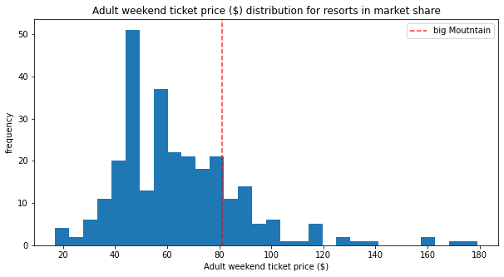 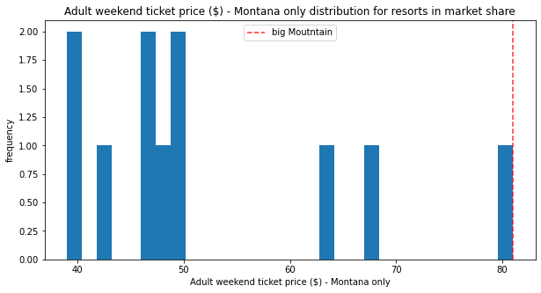

Based on the data shown in all resorts but Big Mountain, there are several strategies that could be used as follows:

1. Closing 5 lease used runs will decrease revenue by 3 million, but also reduce cost, which we do not have information about.
2. Adding a run with an increased vertical drop of 150 feet, that will increase revenue by 2.7 million. But that also requires more maintenance cost, which we do not have information about
3. On top of strategy 2, adding 2 acres of snow making, will increase the revenue by 0. So adding snow making does not help when vertical drop is added. So this strategy should not be taken.
4. Increase the longest run by .2 miles and add snow making by 4 acres, and this does not increase any review. So this strategy should not be taken.

It requires further information bout maintenance cost per run to weigh if strategy 1 is better/worse than strategy 2. According to the price comparison with other mountain resorts, strategy 1 seems like a better choice, if no further information is given.